



**SM6P07NI Digital Media Project**

**50% Individual Project**

**2022-23 Spring**

**Student Name: Ashraya Singh Khatri**

**London Met ID: 19031980**

**College ID: NP01MM4A190077**

**External Supervisor: Pooja Shrestha**

**Internal Supervisor Rakshak Bhushan Bajracharya**

**Assignment Due Date: Wednesday, Aril 26, 2023**

**Assignment Submission Date: Wednesday, April 26, 2023**

**Word Count: 2954**

*I confirm that I understand my coursework needs to be submitted online via Google Classroom under the relevant module page before the deadline in order for my assignment to be accepted and marked. I am fully aware that late submissions will be treated as non-submission and a marks of zero will be awarded.*

**Abstract**

This documentation gives a brief overview of the research and development aspect of the project for Digital Media Project (DMP). The content of this document provides a thorough explanation to the topic of the DMP, i.e., Low Poly Game Assets. It further explains the use of low poly modelling by indie game developers and it’s rise in the video game industry.

In the field of gaming industry and 3D animation low poly modelling has been an art from the very beginning since low polygonal resolution helps to reduce the render time and greatly speeds up the processing time to model the characters and props. Indie game developers these days mostly choose to create a game with low poly art has it gives them more time to model them and aren’t bothered by deadlines. Artists love to create their own 3D world, but not everyone knows how to model, so they download pre-made assets from resources like Unity or Synty studios. By using these assets, they can customize their scenes as they want and focus on other aspects like lightning, compositing, as can work on their work.

The following documentation contains the research to create a low poly stylized asset used for games. With the help of my supervisors, Rakshak Sir and Pooja Ma’am, I was able to finalize my concepts. My concept for DMP is to create low poly animations and models as assets to be used in-game development. This project will showcase all the research, and software to complete the project.

Contents

Introduction 1

Topic 2

Aims of Project 3

Area of Research 4

3. Target Audience 6

3.1 Primary Target Audience: Game Designers/ Indie Artist 6

3.2 Secondary Target Audience: Gamers 6

4. Product Research 7

14

5. Technologies employed 29

6. Project Plan 30

Resources 32

7. Production Phases 33

Game development Life Cycle 33

**Table of Figures**

# Introduction

This document carries a brief overview of the second coursework for the module “Digital Media Project (SM6P07NI)”. The course covers 50% of the total assessment weight. For this semester the students are required to complete their individual projects and provide their internal and external supervisors the documentation, project files and google drive folder link which should contain overall production process, evidence, and testing of the project.

As mentioned in the previous document, the field of gaming development is a very vast one. But as the future for the gaming industry is on the rise, so have the artists. Many new and upcoming game developers are trying and making their own games. As an Indie game developer, they share knowledge, research and feedback, provide testing for one another. Therefore, this documentation covers the research and knowledge of an individual for creating game assets. It further covers the target audience, the software used, and the resources and techniques used to complete the project.

# Topic

Stylized Low Poly Assets

The topic for my project is “Stylized Low Poly Assets” was inspired by numerous low poly asset packs which were being placed up by Asset artist who were creating amazing and entertaining looking assets for people to enjoy. It contains various different asset pack with different genre for everyone to enjoy.

The overall goal of the project is to provide multiple asset packs to individuals so that they can modify their own games utilizing these pre-made models. The project includes eight different asset pack that can be used in a variety of different game settings and environments. These low poly assets pack include 3D models, animation, special effects and particle effects. They’re awesome way to keep the games art looking consistent. The stylized art style gives it a unique visual design.

# Aims of Project

The aim of the project “Stylized Low Poly Asset’ is to simply create a low poly asset pack for the user, as it would lessen their production time and they will be able to finish their project in a faster and efficient way. Since there is rise of many assets’ packs in the internet this not only helps the user to save their time and increase their productivity, it also allows other who don’t have skills in the field of 3D and want to engage in it.

There is a production phases to create assets. There is the pre-production phase where the concept art, storyboard, references and functionality of the game is decided. After the finalization of the concept, during the production phases the production of the project is started. The process of creating assets includes, modelling mapping, UV baking, texturing, shading, lightning and compositing. So, there are many processes out there in the field of 3D. It is very vast and needs a deep level of creativity and understanding which might be time consuming and hard for many. Thus, the market of assets being available as a valuable research are very growing in the video game industry.

The low poly stylized asset includes a variety of different modular meshes, including campfire, outer space ship animation loop, car loop animation, tavern dungeon model and weapon packs. This allows the user to easily modify their game environment without having to focus on modeling and texturing. Low Poly is becoming more and more popular amongst Indie game developers’ theses days, since it is less expensive and easier to create a game on. It decreases their cost and helps boost their production time and quality of the game. They can focus more on their game without worrying about their deadline and boost the quality of the game.

The goal of this project is to make a specific set of stylized assets that an Indie game developer can use it. If a game developer or a player who wants to mod their games or required assets which can be used in certain different gaming scenarios, then this is where the collection of the stylized asset pack comes to play. This helps the game to be more customizable and make the game look unique and beautiful by adding the personalized assets.

Finally, the key objective of this asset pack is to assist the game designers and people who want to learn and utilize more 3D as a stylish game packs that are easily usable and customizable. I hope that the project will also motivate more individuals to learn and experiment with 3D modelling and animation, as well as develop their own unique and creative products.

## Area of Research

The field of game industry is a very vast one. So, the amount of research and creativity is a very large one as well. Form modelling, lightning, texturing, to worldbuilding these topics had to be properly researched before starting the project. Firstly, I researched reference for the modeling.

After I properly researched and used the reference for modeling and started the process. Since, my shading is stylized low poly I began researching and collecting references for it as well. Thus, the research for modeling includes witch’s brew, dungeons, rockets, etc. In addition to the modelling, I wanted to provide animation loop for user could use in their required scenario.

As to further stylize the assets of specific shader there had to be followed to specific modeling with low sculpting and lightning to give it that look. After all the assets and textures that was created for the project were assembled in Blender. Therefore, there was extensive research for the use of the software with proper knowledge of lightning, texturing, shader setup.

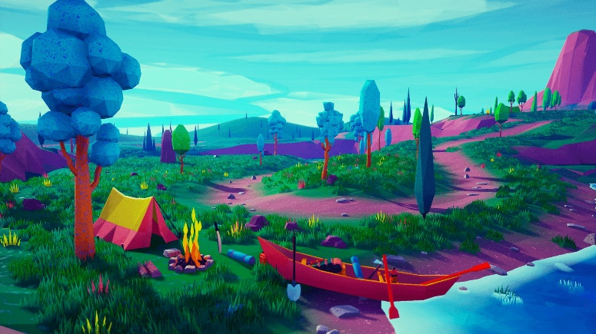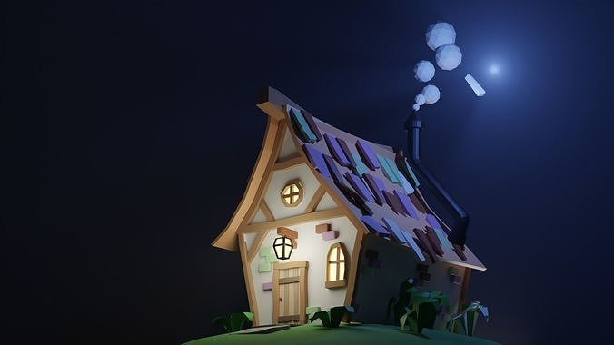

In the images above, on the first one we can see it shows a stylized house with a dark background that focuses and brings more detail to the cottage. As seen in the second image, there is a campfire in the forest with several different color palettes, and the model is utilized as a single material and a texture map with a number of color palettes arranged. So, as such being inspired from this style I haven taken them as a refence for the project.

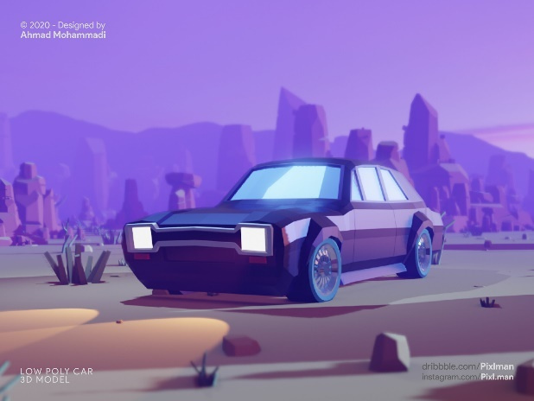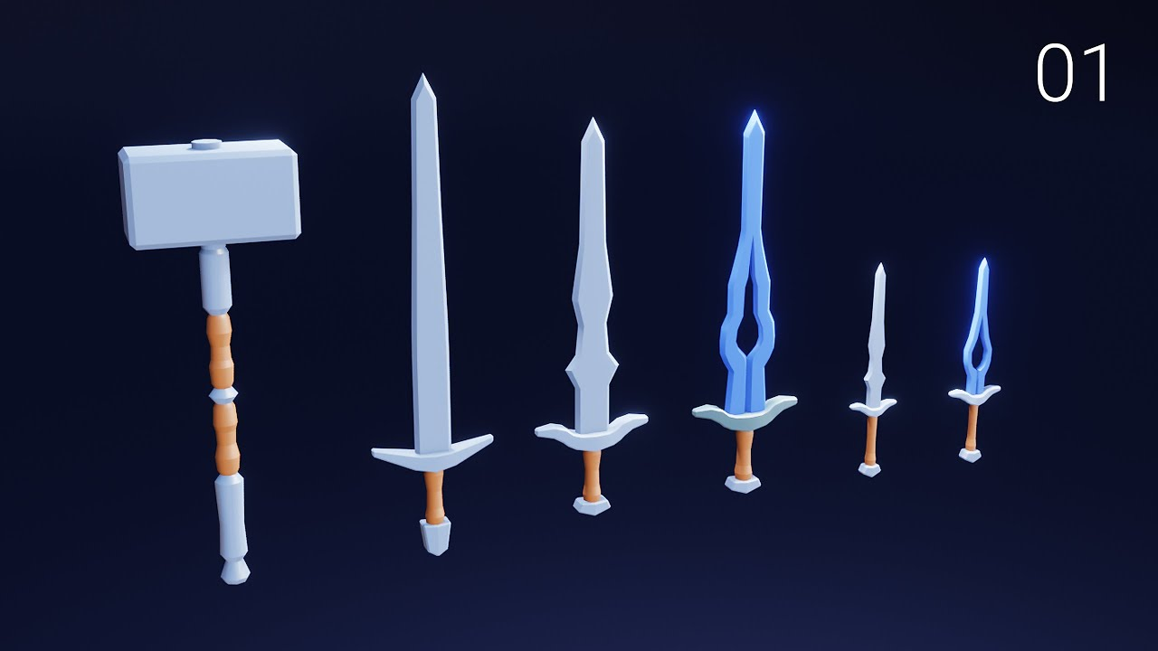

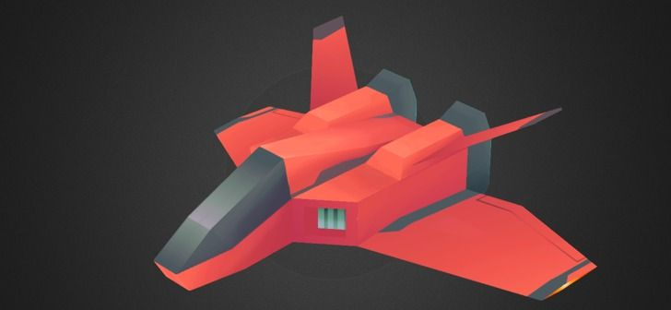

So, to model and animate different asset packs for various game scenarios, I have researched on various low poly models and watched videos and studies about them. Form the above references images, I got the idea and inspiration to model my assets for the project.

# 3. Target Audience

Identifying a target audience is very essential in a project production, there are two distinct audiences which have been researched for this project. Their details have been approached as follows:

## 3.1 Primary Target Audience: Game Designers/ Indie Artist

**Age:** 15 + above

**Gender:** All genders

**Ethnicity:** All Ethnic group of people

**Location:** Throughout the world

**Genre Specification:** Stylized Low Poly pack

As per the research and objective of the project, the primary targeted audience are comprised of the age group from 15 and above. As the process of creating asset is time consuming and leads to being hectic at times. The process of creating assets can be prove useful for them as they can be used for building their own games. This allows them to utilize their time and focus more on their production.

## 3.2 Secondary Target Audience: Gamers

**Age:** 15 + above

**Gender:** All genders

**Ethnicity:** All Ethnic group of people

**Location:** Throughout the world

**Genre Specification:** Stylized Low Poly pack

As per the research and objective of the project, the secondary targeted audience for the product are gamers or people interested in the field of 3D modelling. As there are gamers or viewers who want to use different 3D modelling software to customize their games. In gaming Industry modification of a game is very popular. Gamers or modders can use the assets and customize the games as their choice and release it in the market.

# 4. Product Research

While researching the contents for my DMP, I came across a new software that was not taught to us here in college. I used Blender to complete my project, and I acquired many new tools and techniques from there which I have employed in my project.

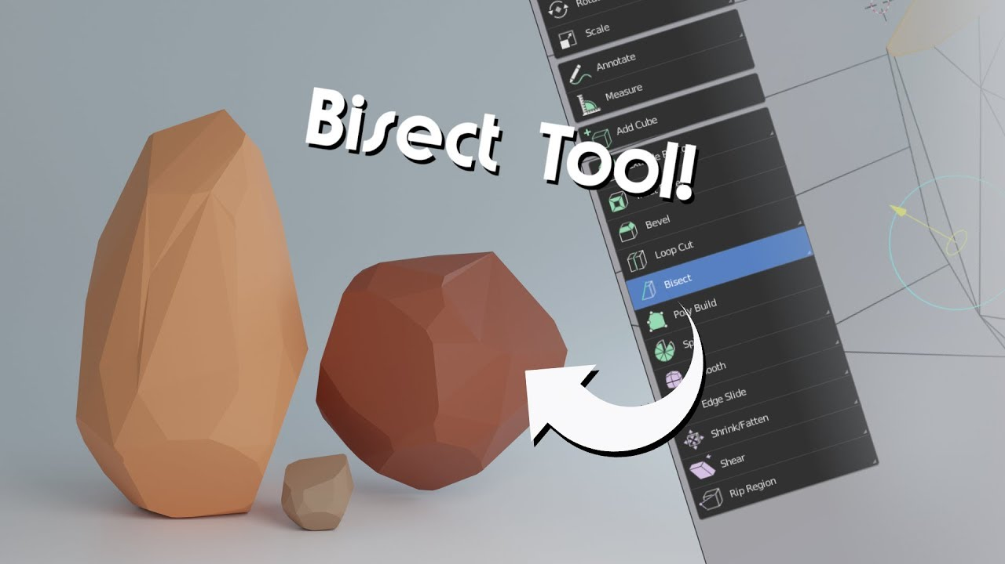

As I started Blender, I leaned many new tools and techniques. Bisect tool is a very useful for low poly modelling. It helps in a quick way to cut a mesh in two along a common line. After selecting the object, we can bisect it in any three-dimensional axis. The tool allows us to bisect the object to clear in or clear it out. Clean in or clear outer removes the geometry on one side. Whereas the option fill allows us to cuts which can optionally make up the gaps they create with materials, UV maps, and vertex colors dependent on the geometry around them. I have used the bisect tool in my project to model low poly stones.

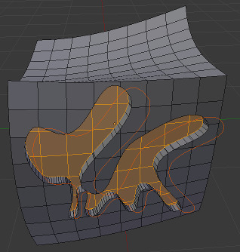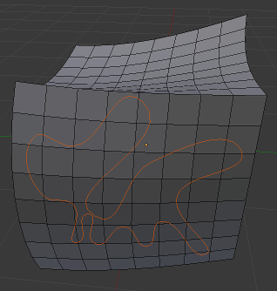

Another very useful tool is the knife tool. The Knife tool can be used to reroute geometry in order to clean up the overall mesh topology. While activated, you can freely "draw" a series of vertices along many faces around your object. Begin by selecting an object and going into Edit Mode.

To activate the new edge, press Enter. The vertices you've added to your mesh are now active and modifiable. This gives you a lot more options than just using the loop cut tool. With the knife tool, any shape can be manually applied to a mesh.

To activate the new edge, we can press enter. The vertices which are added to the mesh now become active and modifiable. This allows us a lot more options than just using the loop cut tool. With the knife tool, any shape cab be manually applied to a mesh.

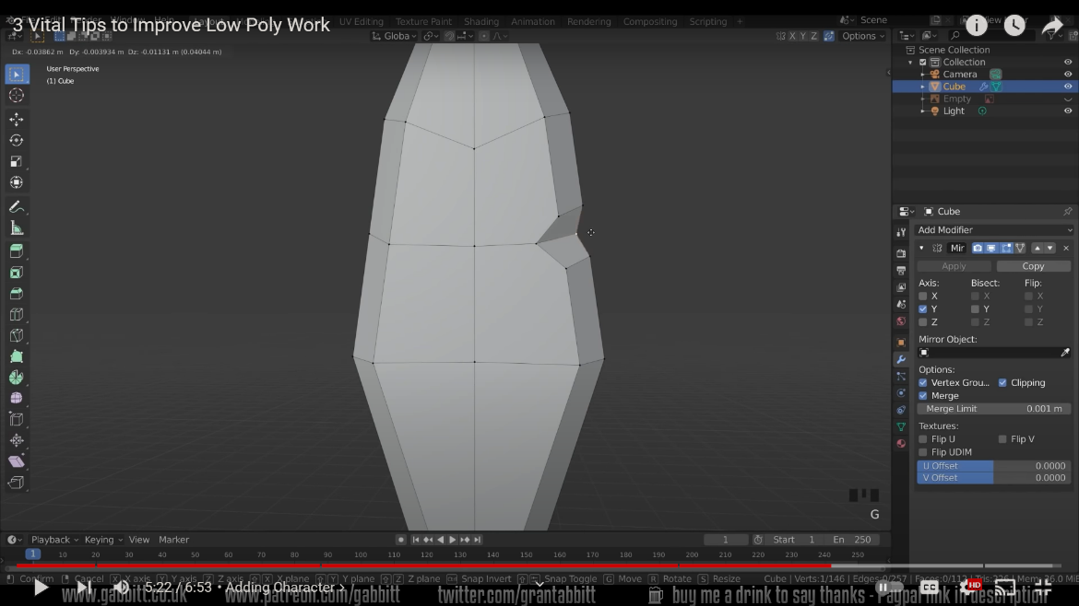

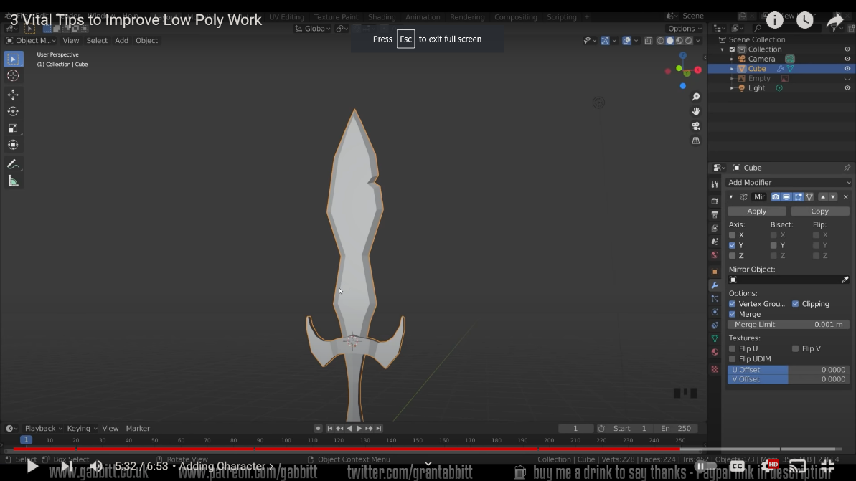

Making a low poly model and giving it a more stylized look by adding and toying with the edges and beveling allows us to add a little more character. Bevels are simple to create, especially in low poly shapes.

While making a low poly model if we want to give it a more stylized look we can add play with the edges and vertices, then bevel it as it allows to add a little more character to the object. Bevels are simple to create, especially in low poly shapes.

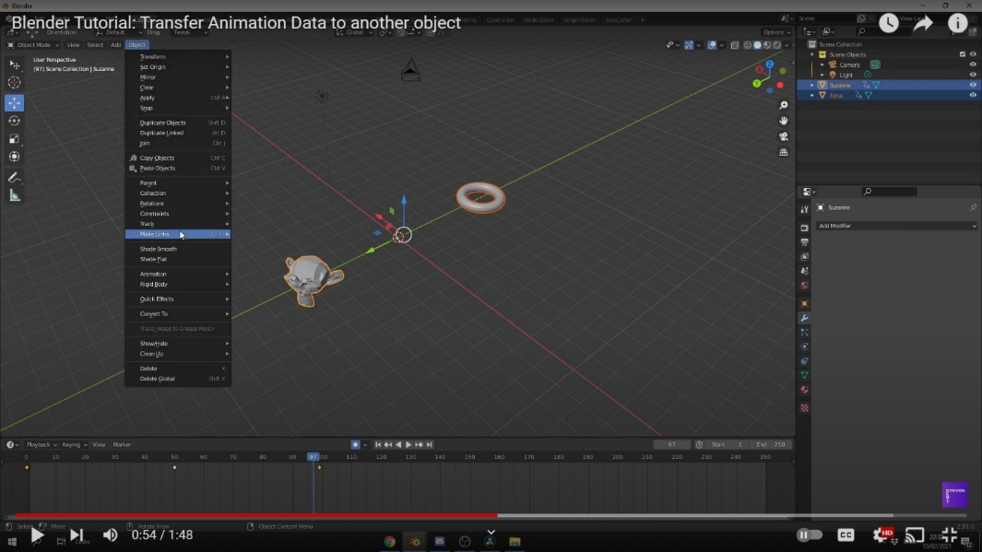

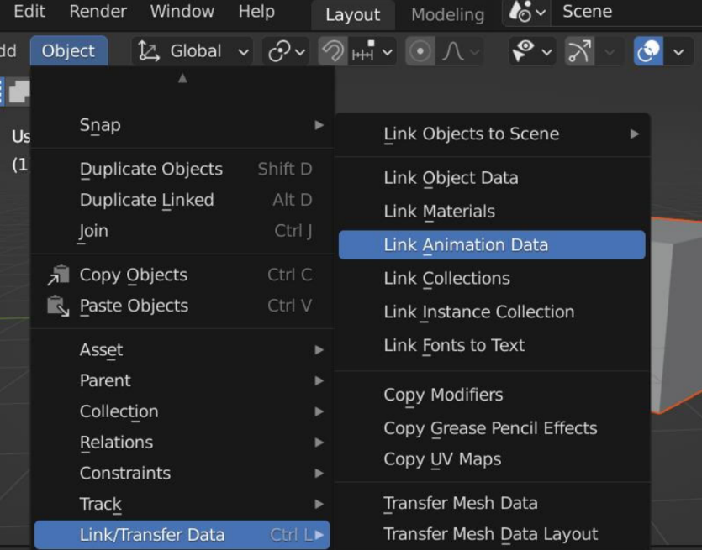

Since, I am also making short animation loops, I am going to use the same animation data at three or four similar objects. For this I have researched how to copy and transfer animation data from one object to another. To copy and transfer data from one object to another we can follow the following steps as mentioned below:

* Firstly, go to the Object
* Then scroll down to the Link/Transfer Data
* Then after we can transfer the animation data

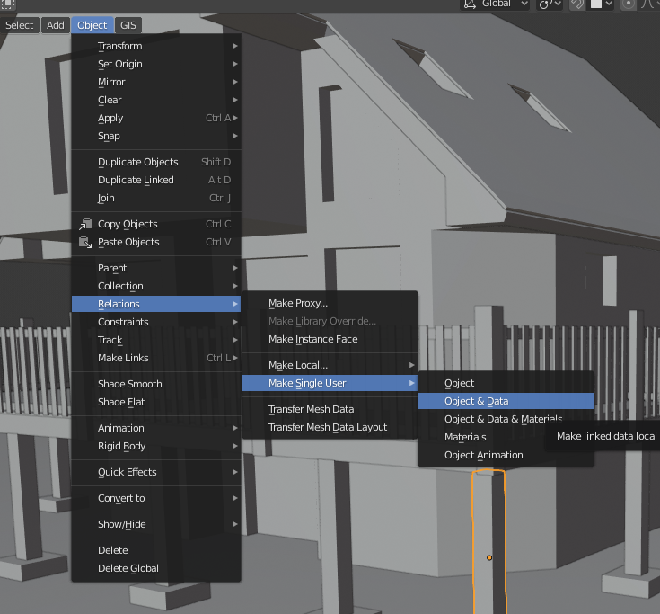

Then the animation data is now linked between the two objects. Whatever the animation data of the selected object is, the transferred object will have the same results. But, the linked animation data can also be changed from one object to another. To do so, select the object copied animation data to ‘Single User’. On the top menu, we can simply go to Object > Relations > Make Single User > Object Animation. This allows us to edit the animation of each object without affecting the other.

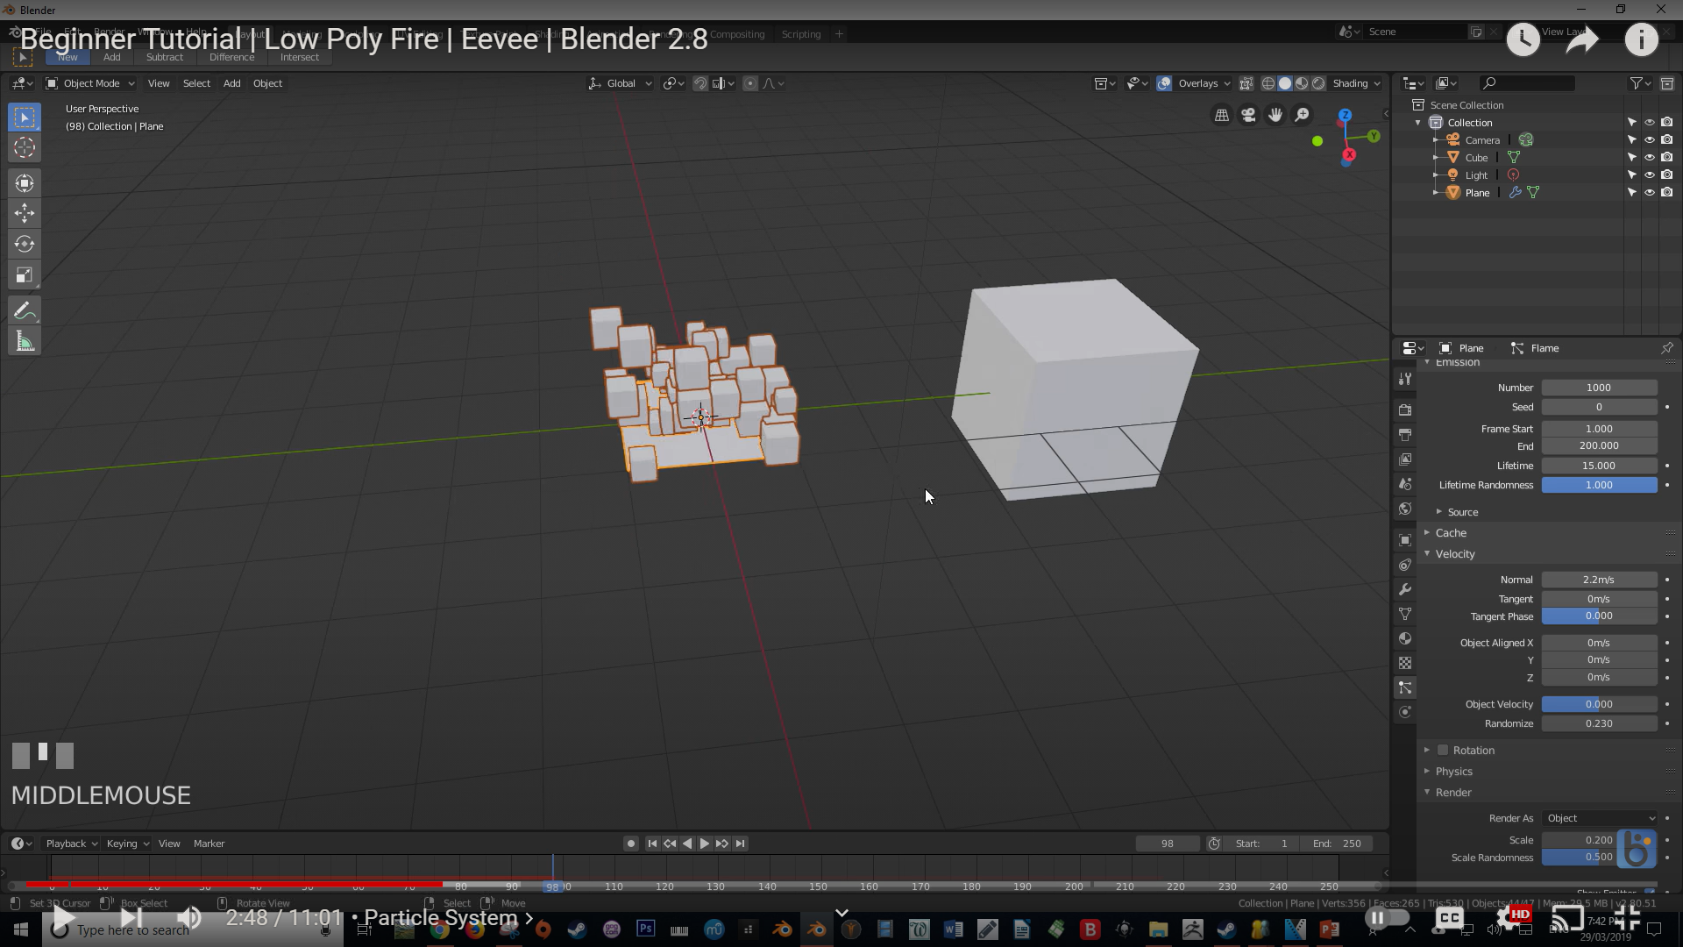

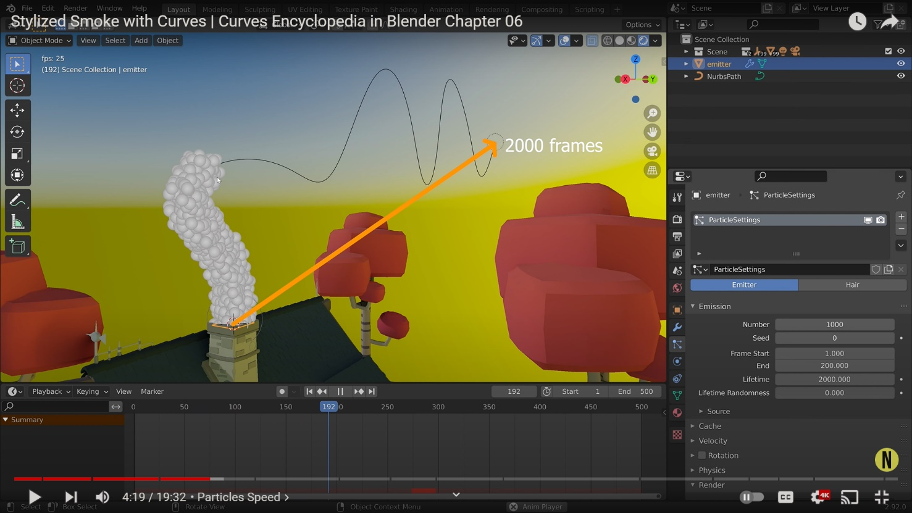

To initiate particles for my project, I have researched more about particle systems. By selecting the object, we can add a new particle system. Then we can play with its emission. We can arrange the Lifetime, velocity and physics. We can set the render to object as it allows us to instance the particles and play with its scale. Such we can change the gravity to make the particles per our environment.

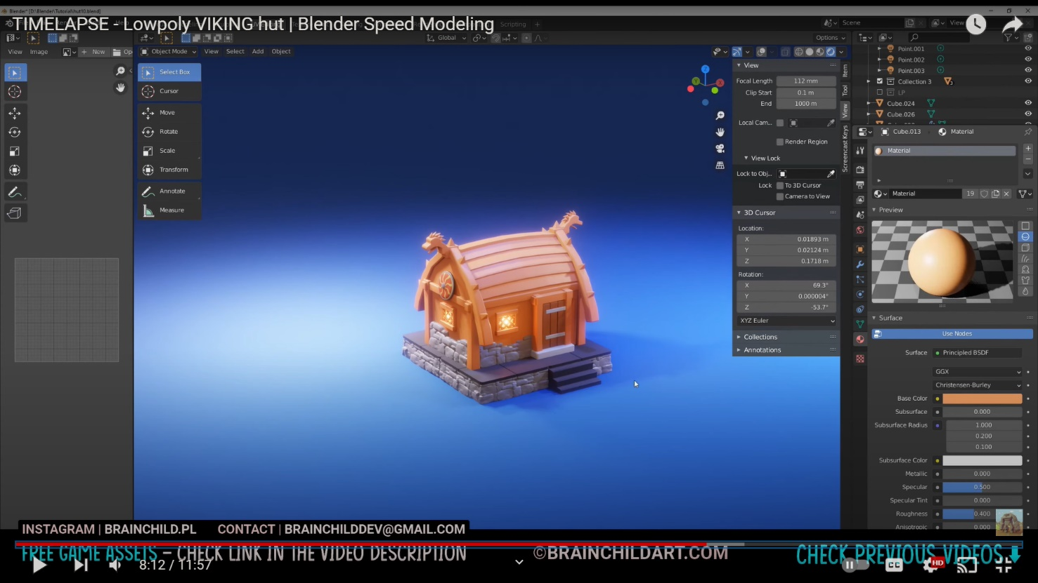

In Blender, materials are the objects that are generated with color, pattern and texture. Shader Editor can be accessed through the Shading tab. The preview is shown on the top screen, while the Shader Editor is shown at the bottom.

The material can be added in edit mode. These switches inform Blender where this material belongs into the Render Pipeline, and which aspects of it should be rendered. There are different materials in which we can render the objects.

Surface materials allows us to render object as a surface. Wire material allows us to render the edges of faces as wires. Volume allows us to render objects as a volume. Halo render halo particles.

# 

If after selecting an object if nothing appears, then then the object lacks material. After clicking the new “+” button at the bottom of screen, a Material is created and a node is automatically created.

The note must be attached is the Material Output node. This node’s connection will be reflected. The default shader is Principal BDSF. The default shader should be disconnected, and after creating another node, drag a line from “BDSF” on the right side of the required node to the material output.

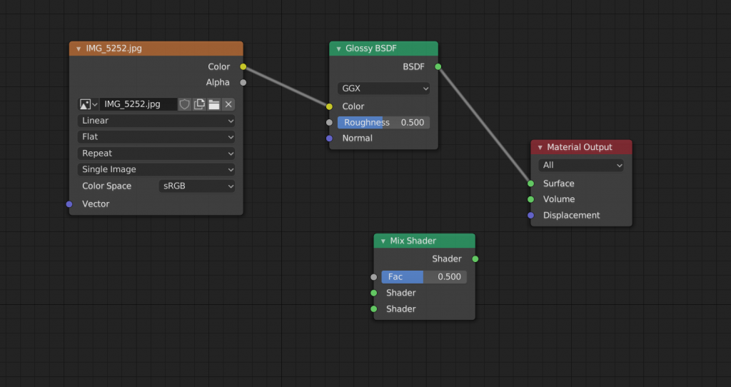

In Node editors it is also possible to combine multiple Shaders.

To do so type [Shift]+[A], then Shader, then Mix Shader. This is the node that will serve as a Shade converter.

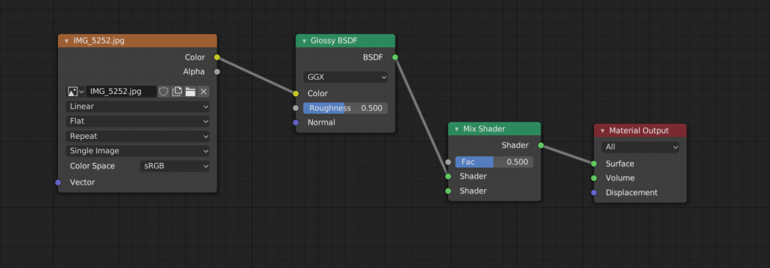

Drag the mix shader node between Glossy BDSF and Material Output.

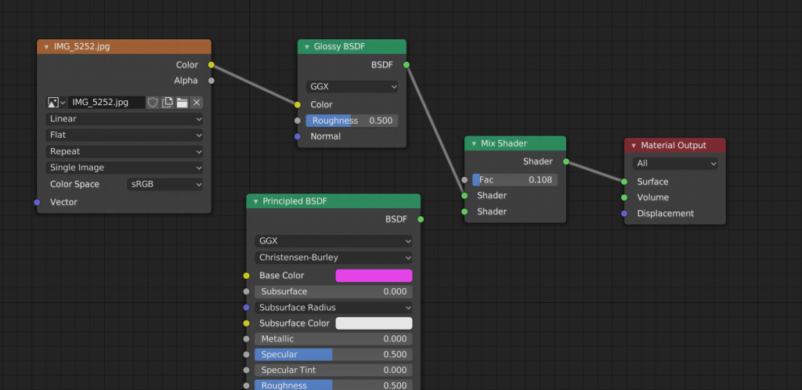

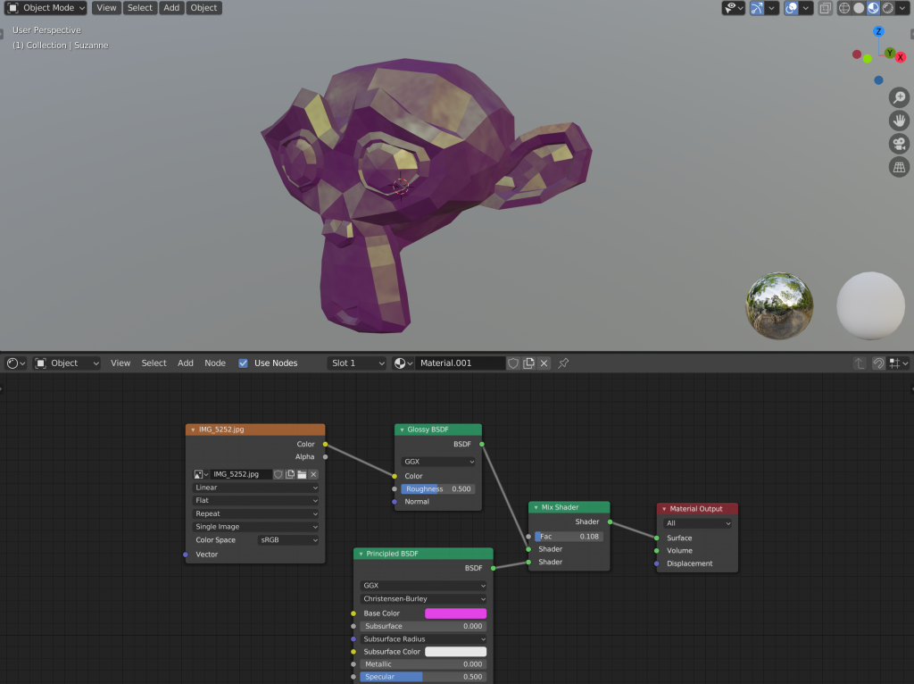

Then another shader is added to the mix. Link the NDSF on the Principle BDSF right side to the shader on the Mix Shader’s left side, leaving two nodes connected to the Shader on the Mix Shader’s left side.

Lighting is one of the most important aspect of 3D modelling to make your scene look more presentable to the audience. It plays a very vital role in pointing out the details and sudden changes in the mood of the scenes to your audiences.

In the world of 3D modelling, 3-point lighting is one of the foremost used technique to make your scene look good.

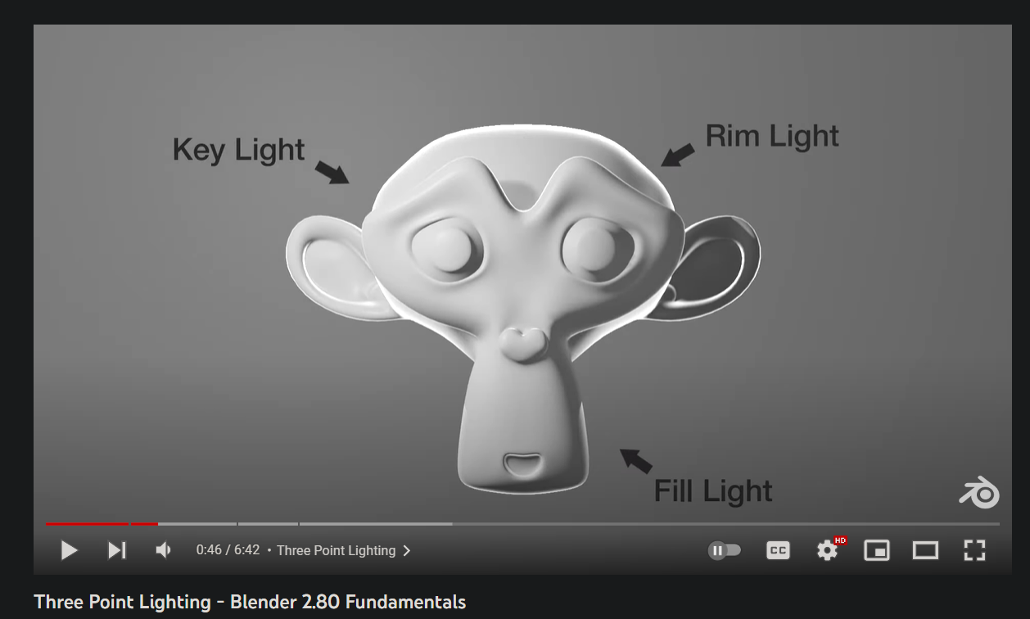

Among the three-light source, the key is light is the primary source of light. It is the primary light source which defines the scene. The fill light softens the shadow that the key light casts upon the mesh. It is the least bright light source amongst the three. It is important because it prevents the shadow from being too dark on the subject. Rim light also known as the back light is cast on the backside of the subject. It is the brightest light amongst the three. It usually just gives a slight touch of brightness on the edge of the subject. This helps the subject stand out from the background.

Key light

It is the first and the most important light source. It is critical for establishing overall lighting for the scene. It should be the most intense light of the three, and should focus on the subject’s form and its depth.

It is normally set up at a 45 – degree angle to right of the camera. While this setting may work for most of the time, it is very dependent on the scene and varies from every 3d artist.

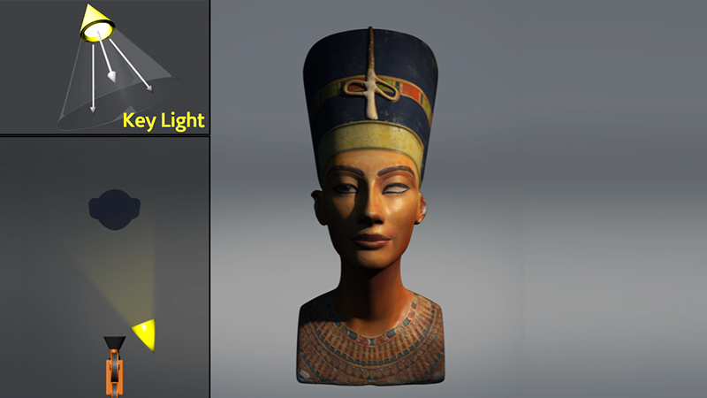

Fill light

The goal of the Fill light is to fill in the deep shadows which is cast upon the subject by the key light. It is often placed on the opposite to the primary light and has lower intensity. Having the fill light’s intensity set too high might cause the scene to be blown out. Setting the fill light just to be bright enough to illuminate the areas where the key light cannot reach is very essential. This helps the detail to be more visible, and gives the shadow a depth

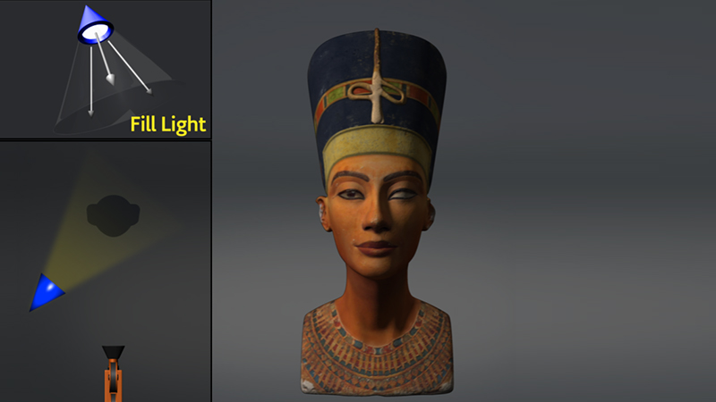

Rim Light

Make sure the rim light does not cast any direct light on the subject. If you hide the key and fill lights, you'll notice that the subject is darkened all around save for a little glow around the margins.

The rim light also known the back light is the final spot light. It is often placed behind the subject. It mainly faces the camera which provides the least amount of illumination effects. While changing the angles of the camera may help to create the desired effect for the scene. Its main purpose is to create a very subtle glow to the back of the subject. Making sure the rim light does not cast any direct light on the subject is very important. This allows the subject to gives a pinch of brightness to glow up the scene.

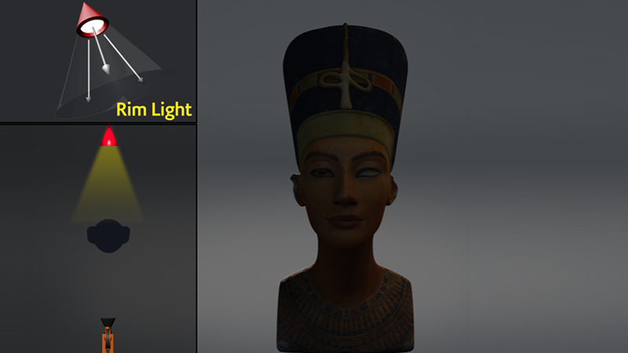

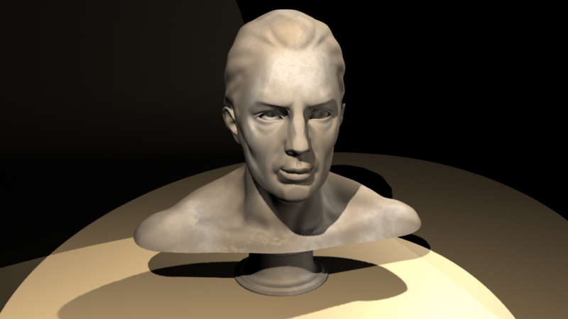

The approach to the 3-point lightning has taken the world of 3D. It has been seen in a numerous of contexts, including product visualizations, character t-pose, etc. De to the unique lightning results which can be achieved relatively rapidly, it has quickly become more and more the go-to lighting techniques for many 3d projects. In addition, while creating a still image or spotlighting a single product or mesh, 3-point lighting is is very ideal which helps to achieve a studio- like lighting aesthetic.

It depends on the subject which is being illustrated (or the absence of a background), altering the settings in contrast to the subject rather than the background proves to be much more convenient. This is due to the lights may have bad results on the background.

There are two render engines in Blender, Eevee and Cycle. For my project I have decided to use Eevee. It is a Realtime render engine developed with OpenGL which focuses on the speed and interactivity while rendering PBR materials. It is used interactively in the 3D Viewport, but can also generate high – quality final outputs.

It is not a raytrace render engine. Instead of processing each ray of light, Eevee uses a technique which is known as rasterization. Many techniques are utilized in rasterization which approximates how light interacts with the objects and materials. While Eevee is intended to follow the PBR concepts, it has its own shortcomings.

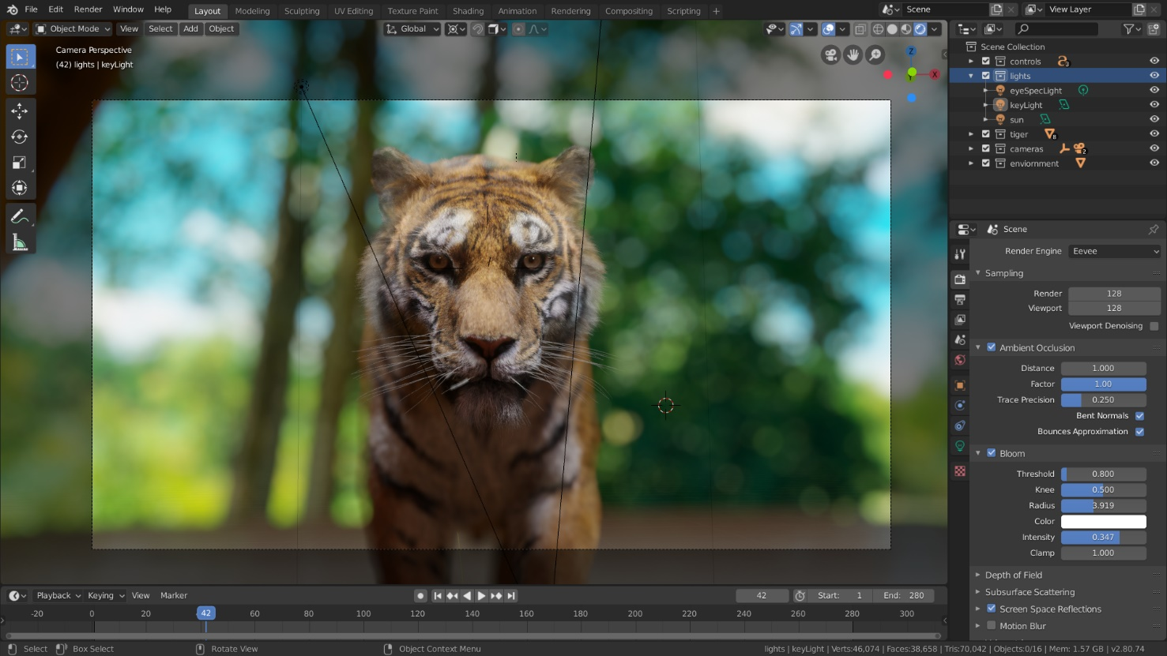

In Eevee render engine, GTAO is used in order to calculate the ambient occlusion, which is then used to indirect lighting. In the render layers tab, we can render ambient occlusion as a distinct pass.

There are many settings that need to be played with while using ambient occlusion panel. This effect must be used in order for the Ambient Occlusion node to work.

Distance: It calculates the distance between the object and the ambient occlusion effect.

Factor: Determines the blending factor for the ambient occlusion effect.

Precision Trace: This increases the effect precision but also intrudes new additional noise which reduces the maximum trace distance. It increases the precision rate alongside the cost of performance. The lower precision may also result in occludes being missed and may cause under shadowing.

Blending Normals: It determines the least obstructed direction.

Bounce Approximation: It is an approximation for simulating the light bounces, which then results in less brightness or occlusion of objects. It just considers the surface hue and not it’s surroundings. The ambient occlusion pass does not get affected by this.

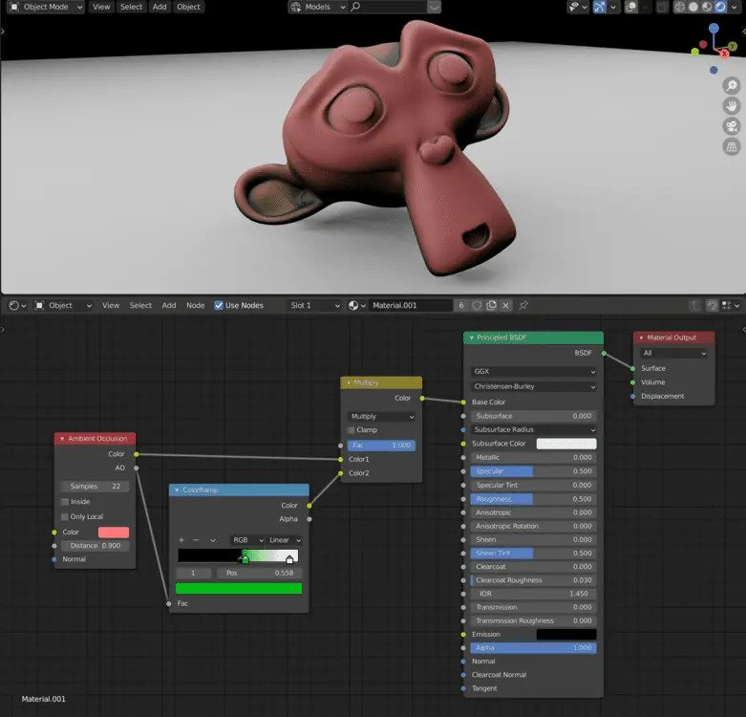

Bloom is a post- processing effect which softens extremely bright pixels. This simulates the lens artifacts which is seen in real life cameras. This allows a proper knowledge of the true intensities of the pixels.

While using Bloom Rendering Panel these are the effects that should be handled.

Threshold: this filter removes pixels which are way too dark.

Knee: This allows for a more gradual shift from beneath to over the barrier. This measures the spread distance of the radius Bloom.

Color: It is the color used in the bloom effect.

Intensity: It calculates the intensity of Blend Factor.

Clamp: It calculates a bloom pixel’s maximum intensity.

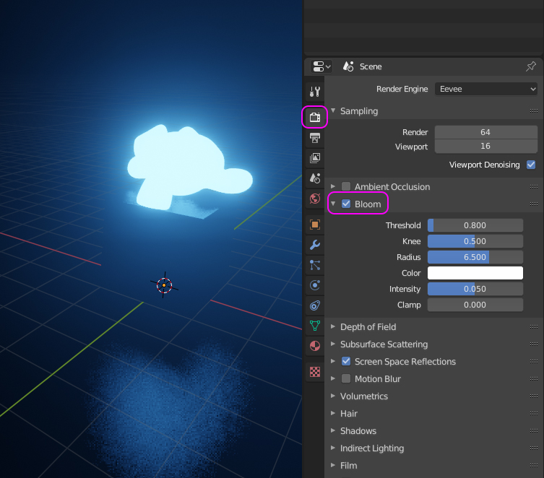

We can distort the diffuse lighting in screen space, to stimulate genuine subsurface scattering. A number of effects can be used in order to render with Subsurface Scattering.

Samples: It is the number of samples that are required to compute the scattering effect.

Jitter Threshold: The jitter threshold when increased causes the samples below the radius percentage to rotate in random manner, which masks the visible pattern. For the effect to be utilized, the samples must be united rather than random. If the scattering radius is big, this will have an effect on the performance.

The Subsurface Translucency must be enabled in order for the light to pass through such items. For example: replicating a human ear light from its behind. This option can only work with darkened lights and does not function with brighter lights.

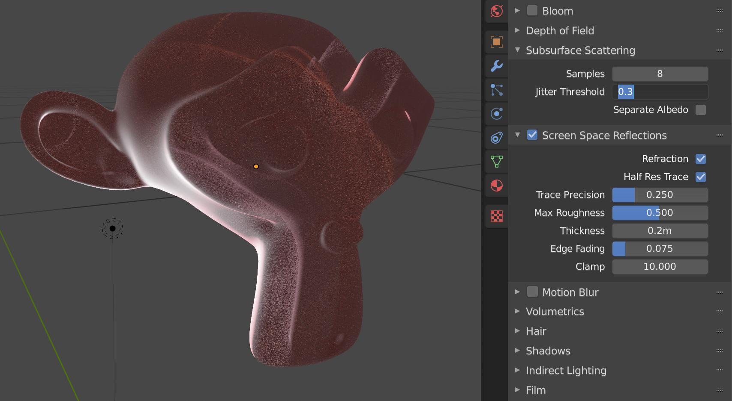

One of the products that I researched for my project was a stylized forest asset pack by Synty studios.

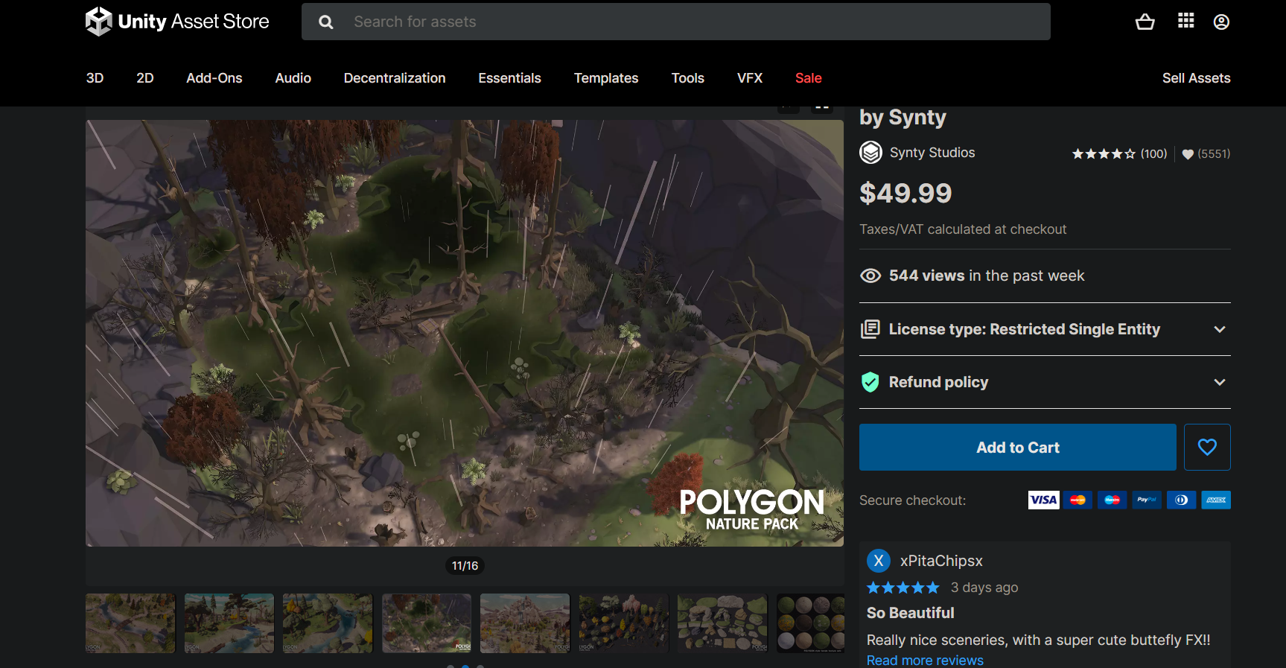

• Supported Platforms: Windows and MacOS

• Supported Unity Versions: 2019.4.28 or higher

• Download Type: Asset Pack

* Review: The asset packs include low poly trees, plains, terrain, rocks, and so on. It fits a variety of aesthetics and spans the gap between polygonal and more traditional styled components. It is a complex landscape texture with clean tiling normal maps that may be dynamically lighted which is also included in the collection. The asset pack also includes animated plants and trees. Unity makes it simple to customize. It also provides the user with a customizable stylized water shader of their choice. The pack also includes fantastic particle effects such as grass blowing, butterflies, fireflies, and so on. The overview map is helpful since it depicts numerous environmental variations such as rain, sunny mornings, and windy days.

Stylized Sci-Fi Asset

The second asset that was researched was the Stylized Sci-fi Asset pack by Synty Studios.

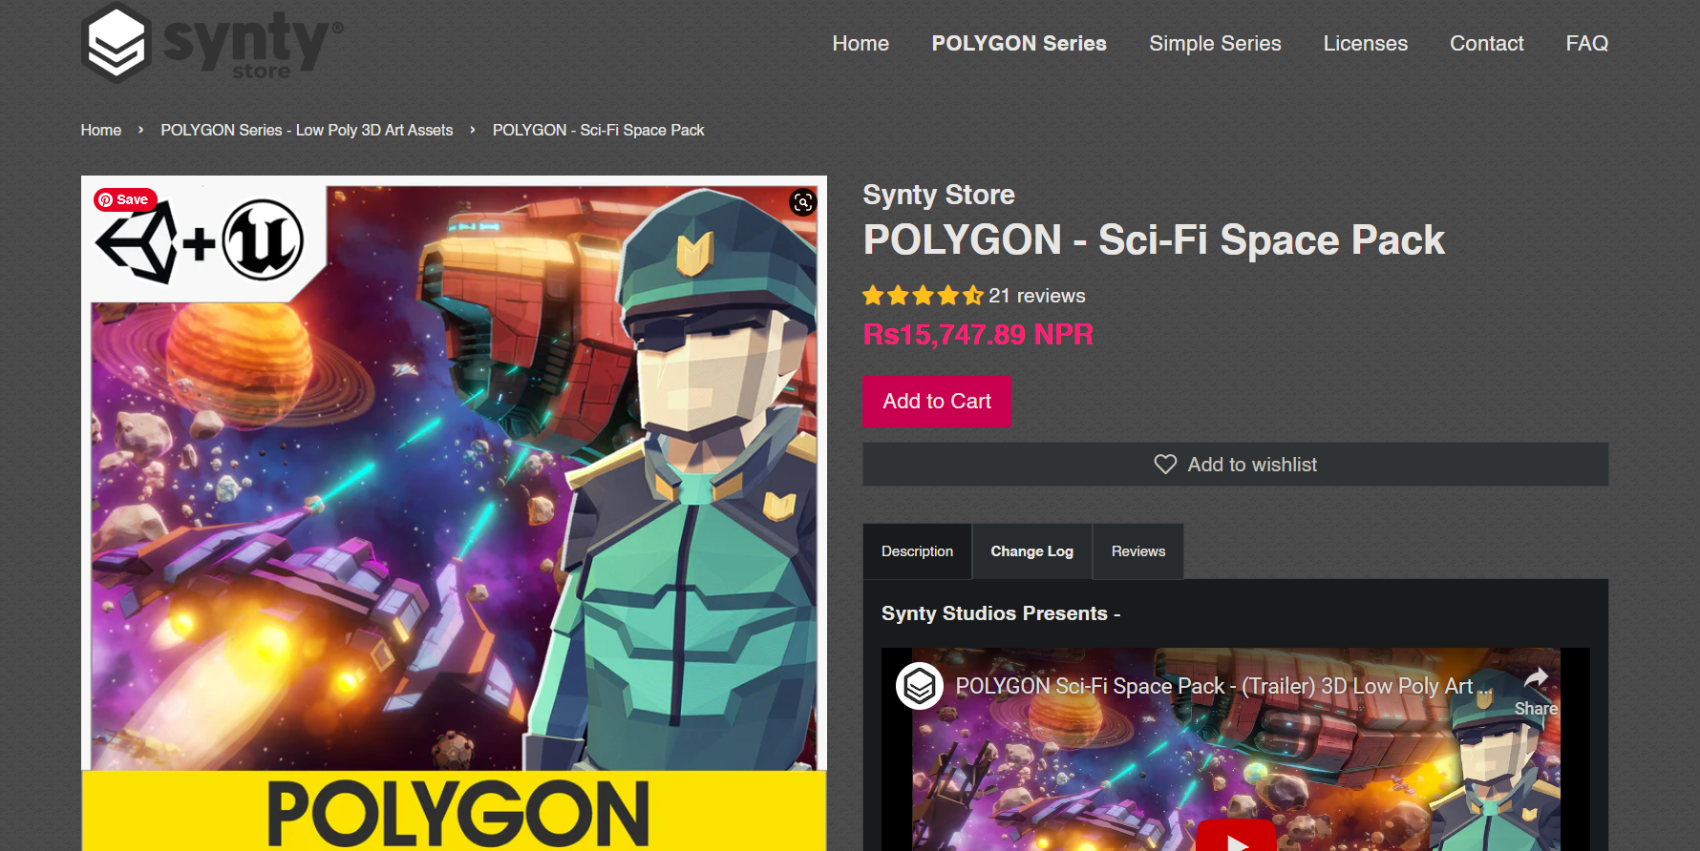

• Supported Platforms: Windows and MacOS

• Supported Unity/ Unreal Versions: 2019.4.28 or higher / 4.26 – 4.27, 5.0

• Download Type: Asset Pack

* Review: It is a low poly asset pack including sci-fi props, weapons, and settings form outer space. The modular section is simple to assemble in a range of ways. It includes detailed props such as drones, escape pods, a space station, and so on. It allows the player to interact with the outside cosmos. The atmosphere appears stylized and gives off a really cosmic vibe that mixes in with the surroundings. The effects, such as the beacon, black hole, and debris, make it incredibly interactive, proving it to be a sci-fi action- packed asset.

Stylized Dungeon Asset

The third and the final asset that was researched was the Stylized Dungeon Asset pack by Synty Studios.

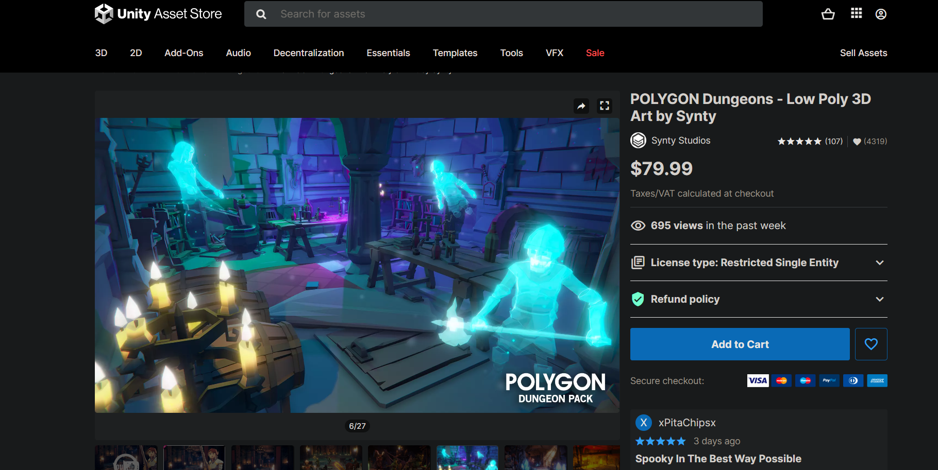

• Supported Platforms: Windows and MacOS

• Supported Unity/ Unreal Versions: 2019.4.28 or higher / 4.26 – 4.27, 5.0

• Download Type: Asset Pack

Review: It is a low poly asset bundle including dungeons which has pack of characters, props, weapons and environment which can be used by the developer to create an epic realm of fantasy low polygonal art game. The asset pack includes modular interior castle set, dungeon entrances, witches brew, weapons, modular goblin camp and to name some few. The atmosphere with the stylized interior brings out the magical realm of fantasy that dives people in it. Low poly weapons design such as hammers, maces, shield provides an additional element to the character.

# 5. Technologies employed

Many types of software were utilized to finish the project. These software were used for modeling, texturing, lighting, and compositing.

Blender

Blender is a popular open- source 3D software. It was developed by Ton Roosendaal, a Dutch art director and self-taught software developer. Blender features includes 3D Modelling, animation, UV mapping and baking, texturing, raster graphics editing, rigging and skinning, fluid and smoke simulation, particle simulation, etc. One of there reason of it’s rise is as it supports the entire 3D pipeline.

Blender is the software that will be used to complete most of this coursework. This software will be sued for low poly modelling, animation, lightning, texturing, camera, rendering and so much more. Blender is one of the most unique software that has various tools that can be used to create low poly models. For animation it allows us to work on it rather than sinking time in the models. The environment will be properly lit with one point and three-point lightning. Similarly, the camera movements are going to be used with proper camera angle to match with the shading and lightning of the model. Once the modelling and animation is completed the whole scene will be rendered with proper settings.

Adobe Illustrator

Adobe Illustrator is the industry top graphic editing software, that allows us to produce and edit logos, charts, illustrations, diagrams, photos, and so on. It includes multiple tools for creating and editing vector images. It is the perfect tool for designers and artists to create and edit digital graphics in high precision.

Illustrator will be used while making the base color or gradient layer for different textures, reference images, concept art and vector designs that will be imported in Blender.

Adobe After Effects

Adobe After Effects is one of the industry leading software for graphic designing motion graphics and visual effects for films and video. It is an excellent tool for editing that allows to make animations, and various effects to moving images.

This video compiling software will be used to composite and edit the final rendered video. With different layers in after effects any changes that needs to be done after the final compositing will be done in after effects.

Adobe Premiere Pro

Adobe Premier Pro is a full- featured software that includes cutting edge editing tools, motion graphics, visual effects, animation, and other features to enhance the final video project. The software is also completely compatible with Adobe Illustrator and Adobe After Effects.

Premiere Pro will be used for editing the video and sound. It will also be used to complete the sound effects and arrange the videos. The final edited video will be color corrected and rendered in proper settings.

# 6. Project Plan

Gantt chart

After the timeline for the production of the project was decided, to create a plan to keep track of the process a Gantt chart was designed. The Gant chart also consists of the tasks that were already completed at the pre- production such as concept finalization and storyboard. To show the production of my project plan the Gantt chart displays the overall workflow of the project. All the steps, including modeling, texturing, compositing is further clarified.

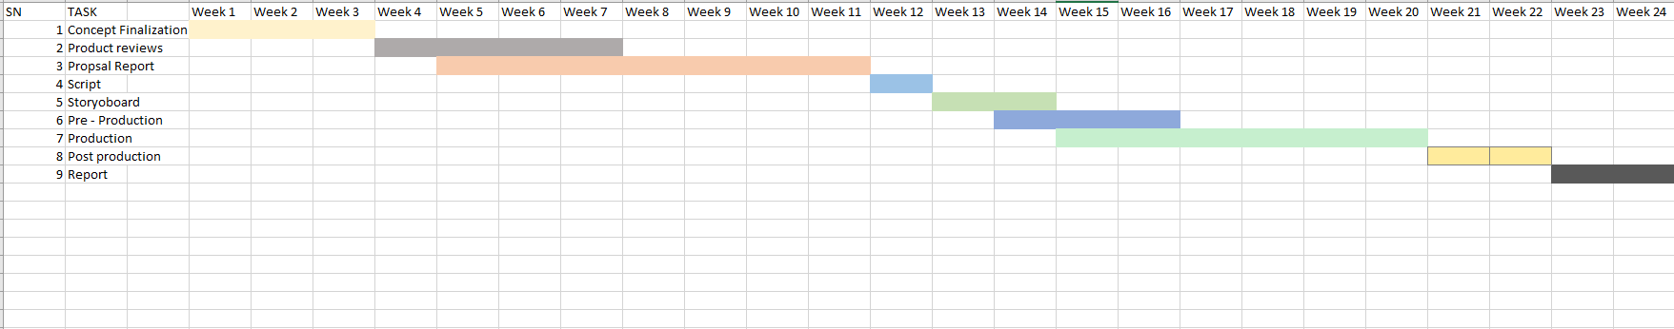

In the timeline and scheduling of the previous coursework, there were lots of process missing and unassigned. This was mainly because at that time the GDLC model process was not followed. However, the work was divided to standard project planning i.e., Preproduction, production, and post-production. The production process was mentioned to start from November of 2021 to May of 2022. Thus, in the second semester this process was reset and started from beginning as more contents and steps were added to the production as per the guidelines of GDLC model.

For the previous timeline of the project, lots of production processes were not properly followed. It was due to lack of a proper model process being not assigned to the project. However, the tasks for the project were divided into standard project planning, Pre-production. Production and Post- production. The production process was mentioned to start from week 15 to week 20. Thus, due to the project not being updated with the previous timeline the initial plan that was done for the DMP was updated with the new Gantt chart.

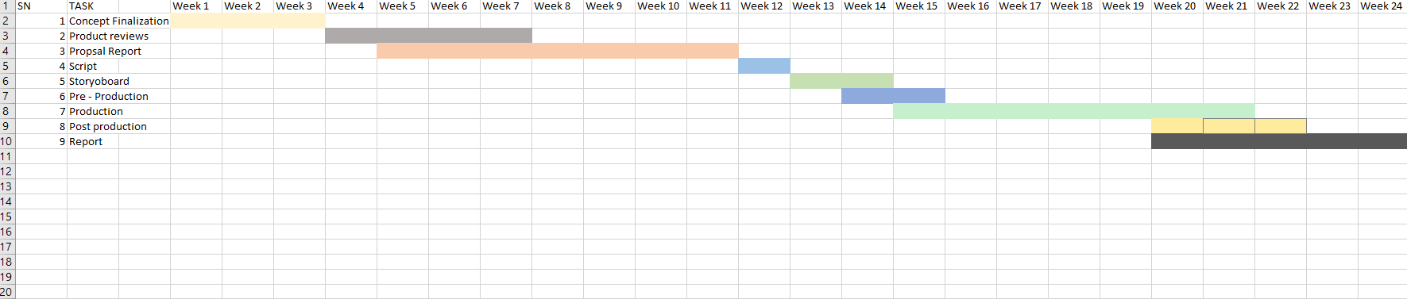

In the early stages, the project was going smoothly. But, with the encounter with some software bugs the project was halted for a while. So, with the new timeline the pre- production process remained same with some changes in the production phase. Following the changes in the model of the production, the contents and scheduling of its processes were matched with the changes. The project contained modelling and animation loops, and I decided to add some particle effects to make it more appealing. So, due to some technical problems and understanding new topics made it time consuming. Thus, the contents and scheduling for the production and prost- production process were updated to match the changes. The production phase duration has increased giving more time to create models with proper shaders and lightning. Post-Production has been moved forward as to render the materials as quickly as possible.

# Resources

A Number of resources were required in order to finish the project. Here, is a list of various resources that was collected and used for the production of the project. The follow resources have been mentioned as follows:

Hardware and Devices

* Acer Predator Helios 300
* NVIDIA GTX 1650TI GPU
* Intel Core7 9th Gen

Software

A total of 4 different software was used in the production of this project. All of this software was used for modeling, texturing, lighting, and compositing.

* Adobe Premiere Pro 2020
* Adobe Illustrator 2021
* Blender 3.4
* Adobe After Effects 2021

Distribution Platform

We were required to upload our project files to GitHub and provide a link to Google Drive. The finished video has been uploaded on YouTube.

* YouTube
* Google Drive
* GitHub

Survey and Testing Tools

When the final product is released online it is ready to be tested just like any other product. With the use of these survey and testing tools, I will be able to better understand and approach the reviews of my product.

* Google forums for survey
* YouTube used to test the playback for modelling and animation

# 7. Production Phases

## Game development Life Cycle

Game Development Life Cycle also known as GDLC is a life cycle of software development with the aim to help the developers follow specific plans to achieve their desired products. Comparing to Software Development Life Cycle (SDLC), developers may face many obstacles while developing games, hence they follow a specific set of planning for developing games.

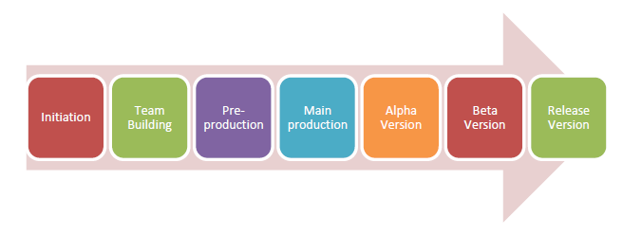

When the game is being released to the general public, GDLC goes through seven different stages, as shown in the above image. The stages are as follows: Firstly, planning what game to produce, deciding on the genre of the game, pre-production: which includes building the

games prototype. The main production includes the games latest version. The alpha version is the unfinished but playable game which is used for alpha testing and fixing bugs and errors. The Beta version is when the game is being tested out by beta tester and released once the bugs are found by the testers and errors have been fixed.

Pre- Production